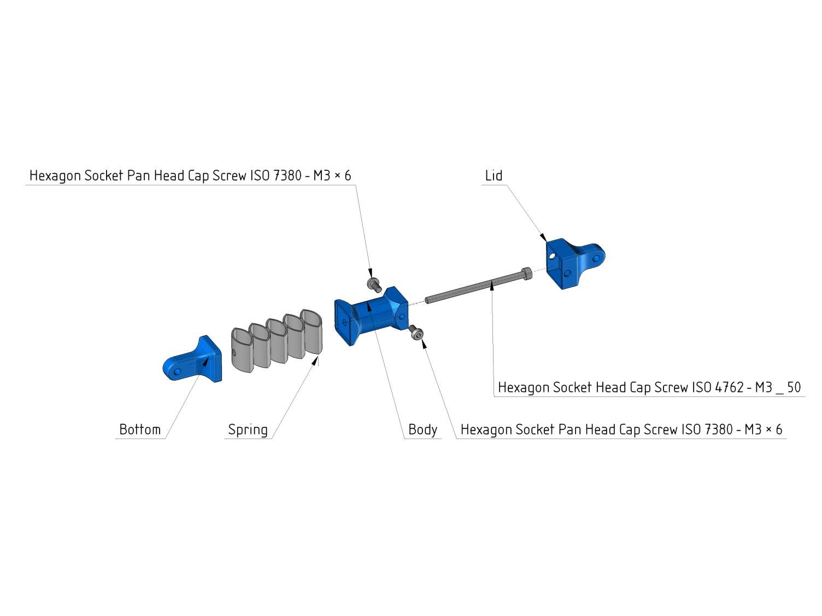

OpenRC Experimental Shocks

While in use, there is a high level of stress on the upper and lower joint and because of that i´ve printed all parts in Nylon. Despite that the only thing that absolutely must be printed in Nylon is the spring.

Use an L-Shaped Allen Key to screw M3x50mm screw in the bottom. You will probably need to compress the spring while doing this.

Then secure the lid with two M3 screws.